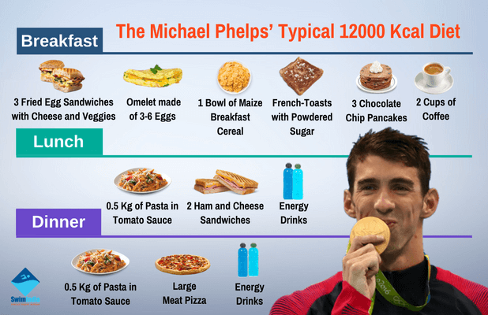Source: <https://swimindia.in/olympic-legend-michael-phelps-a-peek-into-his-holistic-training>

Dryland Training Video: <https://www.youtube.com/watch?v=qoQnsbfMCeI>

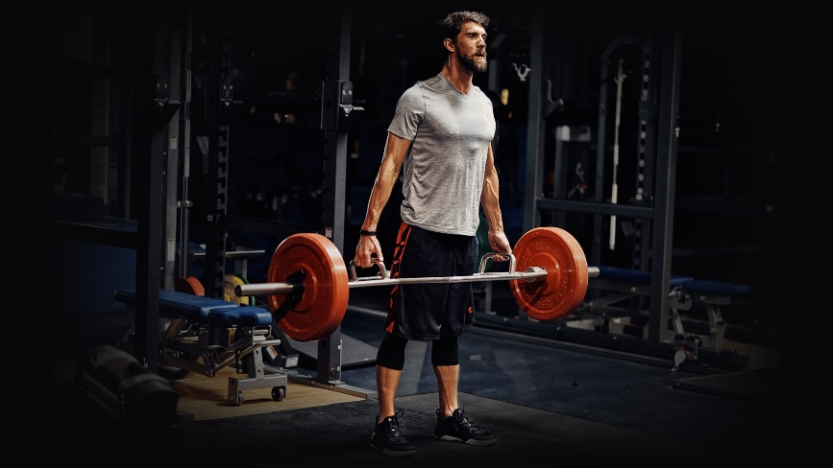 Source: <https://www.complex.com/sports/under-armour-michael-phelps>

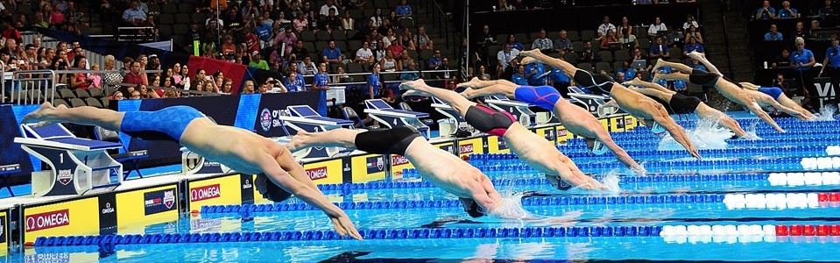source: <https://www.gulfswimming.org/swim-meets/>

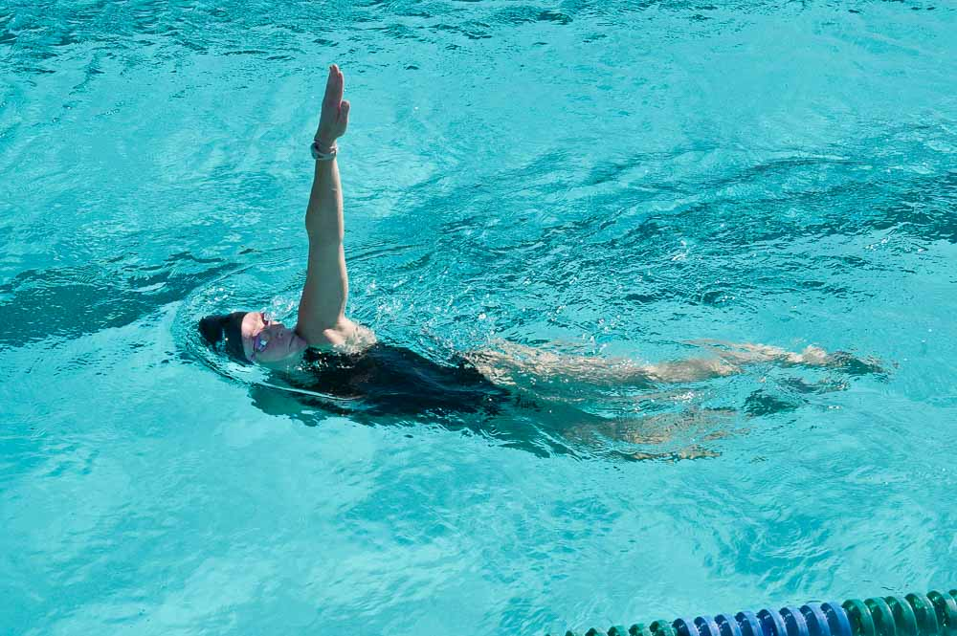 Source: <https://www.usms.org/fitness-and-training/articles-and-videos/articles/reboot-of-some-classic-drills?Oldid=3415>

Hours of Swimming Video: <https://www.youtube.com/watch?v=rSQmIf0ZXeY>